*Heaven’s light is our guide*



[This Photo](https://en.wikipedia.org/wiki/Rajshahi_University_of_Engineering_%26_Technology) by Unknown Author is licensed under [CC BY-SA](https://creativecommons.org/licenses/by-sa/3.0/)

**Rajshahi University of Engineering & Technology**

**Course no:** EEE 2100

**Course title:** Electrical Shop Practice

**Project no:** 01

**Project title:** Electrical safety uniform and equipment.

**Submitted to:**

**Dr. Muhammad Abdul Goffar Khan**

Professor

Department of Electrical & Electronic Engineering,

Rajshahi University of Engineering & Technology.

**Submitted by:**

**Ashraf Al- Khalique**

ID: 1801171

Section: C

Session: 2018-2019

Department Electrical & Electronic Engineering,

Rajshahi University of Engineering & Technology.

**Date of submission:** November 24, 2020.

**Project no.** 01

**Project Title:** Electrical Safety Uniform and equipment’s.

**Objectives:** The main objectives of this project are:

1. To ensure worker safety in the working place.
2. To keep the workers up to date with best safety tools and practices.
3. To educate workers about the proper protection requirement in hazardous workspace.

**Apparatus:**

* 1. Safety footwear
  2. Safety belt
  3. Safety glasses
  4. Safety helmet
  5. Protective gloves
  6. Mask
  7. Visibility vest
  8. Fire extinguisher

**Project Picture:**

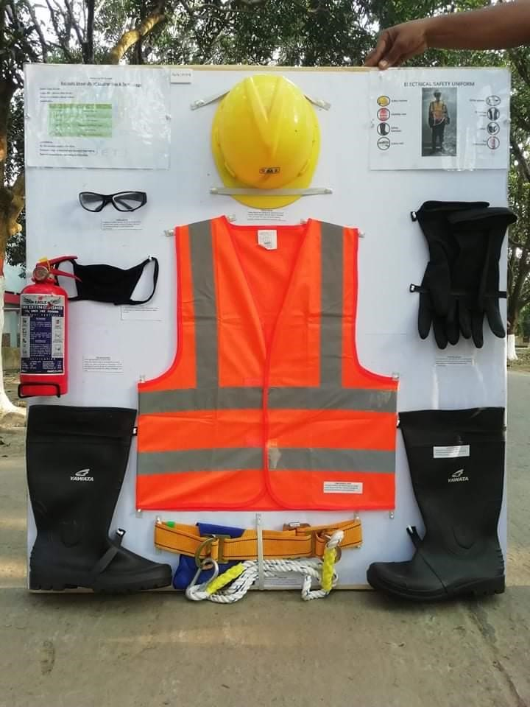

**Equipment details:**

1. Safety footwear: These footwears provide a secondary source of protection for you from electric shocks or electrocution. They also provide a protective reinforcement in the toe which protects the foot from falling objects or compression, burns, cuts, punctures, and impact.

2. Safety belt: A safety belt is a device that is worn around a person's waist to serve as a direct connection point to a lifeline or elevated structure. It is worn to arrest a fall and protect a worker from a sudden descent and associated hazards when working at an elevated height.

3. Safety glasses: Safety glasses are intended to shield the wearer's eyes from impact hazards such as flying fragments, objects, large chips, and particles. Glasses or goggles fit the face immediately surrounding the eyes and form a protective seal around the eyes. This prevents objects from entering under or around the goggles.

4. Safety helmet: Safety helmets are personal protective equipment designed to protect the upper part of workers' heads from falling or flying objects, impact, burns, and electrical hazards. In the construction and mining industries, workers must be equipped with safety helmets. Helmets are designed to resist perforation, water, and fire.

5. Protective gloves: Protective gloves are needed to prevent injuries to the hands and to comply with the hazard prevention hierarchy.

6. Mask: This is used to avoid any direct contact with unknown gas, smog, and smokes that may be an impedance in the working process.

7. Visibility vest: High-visibility vest is any clothing worn that is highly luminescent in its natural matt property or a color that is easily discernible from any background. Most industrial employers require it as a type of personal protective equipment (PPE).

8. Fire extinguisher: A fire extinguisher is an active fire protection device used to extinguish or control small fires in emergency situations. It is not intended for use on an out-of-control fire, such as one which has reached the ceiling, endangers the user (i.e., no escape route, smoke, explosion hazard, etc.), or otherwise requires the expertise of a fire brigade. They can be categorized as ABC, whereas,

I. Class A is for trash, wood, and paper

II. Class B is for liquids and gases

III. Class C is for energized electrical sources

**Result:** Unfortunately, no physical usage was done using these equipment’s.

**Discussion:** All of these electrical safety uniform and equipment were bought by the group members together. At the end of the purchase, they were showcased on hard board.

**Bill of materials:**

# Bill of Materials

**Date:** March 03,2020.

**Title:** Electrical Safety Uniform & Equipment’s.

|  |  |  |  |  |  |  |  |  |
| --- | --- | --- | --- | --- | --- | --- | --- | --- |
| **SL.**  **No.** | **Date** | **Voucher** | **Name** | **Specification** | **Quantity** | **Rate**  **in**  **BDT** | **Cost in BDT** | **Comments** |
| 1 | 15-02-2020 |  | Safety footwear | A pair of safety footwear/boots were bought to provide a secondary source of protection from electric shocks or electrocution. | 1 no. | 600 | 600 |  |
| 2 | 15-02-2020 |  | Safety belt | A positioning type safety harness was brought. It doesn’t have a shock absorber but may be used for applications that require positioning or worn to arrest a fall and protect a worker from a sudden descent | 1 no. | 450 | 430 | Taka 20 was discounted due to buying many items. |
| 3 | 15-02-2020 |  | Safety glasses | DEWALT Clear  Anti-Fog  Protective Safety Glasses were bought to reduce the chances of an accidental electrical discharge and helps to minimize injury during an electrical accident. | 1 no. | 50 | 50 |  |
| 4 | 15-02-2020 |  | Safety helmet | A Yellow helmet for general laborer’s or earth-moving operators were bought. It is primarily designed for protection against accidental falls and protection from falling objects and additional protection from overhead live wires while working on live lines. | 1 no. | 200 | 200 |  |
| 5 | 15-02-2020 |  | Protective gloves | A pair of black gloves for protection of the hands while performing tasks involving chemicals and electrical was bought. | 1 no. | 100 | 100 | A pair of reusable butyl gloves was brought. |
| 6 | 15-02-2020 |  | Mask | This is used to avoid any direct contact with unknown gas and smokes that may be an impedance in the working process | 1 no. | 50 | 50 | Due to shortage of professional mask, a clothing mask was brought. |
| 7 | 15-02-2020 |  | Visibility vest | A vest of orange color was brought as it provides high visibility. They are mainly used in the construction site as it is highly luminescent in its natural matt property. | 1 no. | 400 | 400 | Although there were 2 type of visibility vest (yellow & orange), we didn’t buy the yellow one as its mostly for emergency situation. |
| 8 | 17-02-2020 |  | Fire extinguisher | ABC Dry Chemical, or multi-purpose dry chemical fire extinguisher was brought to stop the chain reaction by smothering. | 1 no. | 700 | 700 | It was brought from the local fire station with proper guidance and by following general procedures. |
| 9 | 24-02-2020 |  | Saddle nail clip |  | 50 nos. | 1 | 40 | Taka 10 was discounted due to buying many items. |
|  |  |  | | Total cost= |  |  | 2570 |  |

**Prepared by:**

**Ashraf Al- Khalique**

ID: 1801171

Department of Electrical & Electronic Engineering.

Rajshahi University of Engineering & Technology.

**Checked by:**

**Dr. Muhammad Abdul Goffar Khan**

Professor

Department of Electrical & Electronic Engineering.

**Rajshahi University of Engineering & Technology.**

**Approved by:**